**I.Introduction of project products**

It is human nature to love beauty. In view of this feature, we launched the app "Meitu 3D" to solve the needs of the majority of users. "Meitu 3D" app is mainly divided into beauty, fitness,

wear and match three sections, in a three-dimensional way, so that users feel a full range of

beautiful experience.

**1. Beauty section**

Users can use "Meitu 3D", through graphic videos and other forms, at any time to learn beauty

knowledge, correct some wrong beauty practices. How to use hundreds of cosmetics, and how to

make up for different skin and face shapes can all be answered by this APP. At the same time,

Meitu 3D will regularly release cosmetics-related texts, so that users can learn how to choose

various cosmetics suitable for them while reading them, so that they will not be fooled by

shopping guides in shopping malls. The most outstanding feature of "Meitu 3D" is its strong

pertinent. users can click on the facial features of the interactive face to view the makeup in

different areas, but also can choose different styles of makeup through the navigation bar, filter

out invalid information, greatly improve the search efficiency, to provide accurate answers for

customer needs.

**2. Body building section**

The function developed by "Meitu 3D" fitness section has articles and videos related to fitness

teaching. According to different parts and users' different needs, "Meitu 3D" will provide training

and teaching videos with different functions and strengths. In addition, there is a special section

in the fitness section. According to the characteristics of people who keep fit and lose weight, a

wealth of thematic content is recommended, including training videos, music library, action

library and diet topics, to help users develop fitness recipes.

**3. Wear the plate**

"Meitu 3D" wear plate is very practical, very powerful, here brings together a lot of clothing collocation case, you can view at any time, but also according to the weather and user's own situation own situation to give advice on dressing, to help users easily walk in the forefront of fashion!

**Innovation point:**

a) The interactive click mode of face in the beauty plate is relatively rare in the app market, which

fits the needs of users.

b) Pure information app is relatively novel, and users can obtain a large amount of information.

c) The fitness section can analyze the calories of different foods and provide users with the most

appropriate opinions.

d) Wear plate has strong adjustable ability to easily meet users' various needs.

**Ⅱ.USP**

We are committed to creating a targeted, simple and efficient operation of the beauty, wear,

fitness information container app, so that users feel three-dimensional beautiful experience.

**Ⅲ. Market analysis**

**1. New ideas of consumption research in the demand-oriented era**

In our reports "The Third Consumption Era in China -- Rereading and Deconstructing the Fourth

Consumption Era" and "Marketing Is the King Era: From the Transformation of Marketing

Theories to the reconstruction of frame Thinking and target selection Logic", we conclude that

China has entered the early stage of the third consumption era, and the most essential difference

between the third and second consumption era lies in the shift from supply-oriented to

demand-oriented. For enterprises, this change prompts them to change in two aspects: (1) Pay

attention to marketing; (2) demand-oriented product design and development.

In 1990, Professor Lauterbaum proposed the 4C theory to replace the 4P theory. The 4P theory is

the basic framework for our research and analysis of consumer goods. Updating the framework

from the supply-oriented 4P theory to the demand-oriented 4C theory will help us to better

judge the competitive factors of enterprises and analyze their competitiveness. Therefore, our

app focuses on starting from the user needs, is committed to solve the problem of user needs in

all aspects, and build an app that thinks completely from the user's perspective.

**2. Market research**

At present, the mainstream apps similar to Meitu 3D in the market include 'keep', which mainly

provides fitness functions, and 'Xiaohongshu', which is similar to a search engine tool but mainly

focuses on makeup and matching. Similar apps have a high market demand, but all of them have

problems such as the content is too single and can only target specific groups with specific needs,

or the notes are becoming more and more mixed, the credibility is gradually reduced, the

contents are similar, and it is impossible to systematically find the most needed information of

users. And our app is to solve such a problem, by providing a clear information navigation bar,

more accurately judge the information content users need to look for, accurately recommend the

best and highest quality related articles or video tutorials, so that users feel the efficiency and

effectiveness of the app.

The information collected through the questionnaire shows that most people will pay attention

to beauty, dress, fitness and other aspects in their daily life, and have certain needs for related

tutorials. However, it is difficult to find tutorials about beauty, dress, fitness and other aspects on

the Internet system at present, which is a fact recognized by most people. The existing apps on

the market cannot fully meet the needs of most people. They are willing to pursue an app that

can provide them with more comprehensive and systematic help.

**IV. Target user roles**

**1. User positioning**

With the rapid development of the consumer market and the rise of income level,

personal image is becoming more and more important. With the explosive rise of

"appearance level economy", young consumers have become the absolute main

consumption force and the potential fashion force in the future. The online market is

booming, and the consumption potential of people aged 18 to 40 is also being released.

This project is mainly for the contemporary young people and people with certain needs

to develop beauty makeup, wear, fitness in one APP. For contemporary young people aged

18-40, women often cannot do without beauty makeup, while men will also pay attention to

fitness issues, and wearing is also a particular concern of young people.

According to the survey, women are twice as likely as men to use tutorials or apps to

help them (see Figure 1-1). Obviously, our products are more preferred by women, but at the

same time there are some male potential customers. Among the surveyed people, the age

group is mainly between 18 and 40 years old, which indicates that most of the attention and

preferences of our products come from this age group.

In addition, our product is a product developed from daily needs, which is more in line

with today's social trends, and its user positioning will be concentrated in the group

concerned about social trends and fashion.

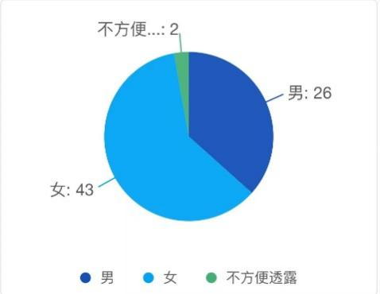

Figure 1-1 Gender

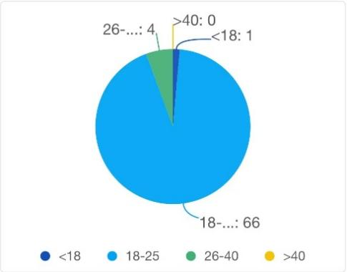

Figure 1-2 Age

**2. User requirements**

Nowadays, with the rapid development of The Times, people pay attention to the

changes of their appearance, which also produce a huge demand. According to the survey,

more than 78% of people have the needs of beauty makeup, clothing, fitness and other

aspects in their daily life (as shown in Figure 2-1), which has even become the daily

necessities of contemporary young people. Women are more willing to use makeup to

improve their facial appearance, while men are more willing to use fitness to beautify their

body. People often rely on clothes to enhance their fashion, but also use them to improve

their body shape.

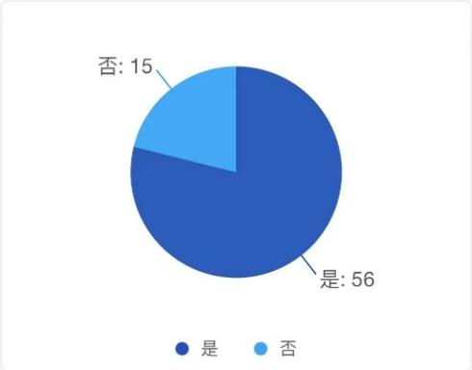

Figure 2-1 Whether there is a need for beauty, clothing, fitness, etc

**a) Beauty**

Makeup has become a necessity for most women and some men. Many people rely on

makeup to achieve beauty in their daily lives, as well as to achieve a dignified effect in formal

situations. For most of us, beauty is a skill we develop later in life. Many people will

encounter problems such as stepping on the trap, product recommendations and so on,

systematic makeup tutorials and high-quality makeup product recommendations become an

indispensable part of the process.

**b) Fitness**

There is a growing need for men to manage their bodies. Both male fitness groups and

many potential female customers have become the user target of this product. The fitness

program not only targets at those who need physical exercise, but also includes many users

who live a healthy life. The system of fitness tutorial and arrangement can avoid the user in

the face of the multifarious tutorials on the market produced visual fatigue, but also

eliminate the market of invisible consumption brought by the trap.

**c) Wear and match**

At present, with the rise of fashion consciousness, it has once become a development

hotspot. People pay more and more attention to the personalized expression of personal

image. As an important way of image building and publicity, clothing and related industries

are booming under the wide attention. However, there are quite a large number of groups

are troubled by clothing collocation, such as the idea of wearing confused, wearing a single

style, collocation effect is not satisfied, clothing idle rate is high. Although there are a lot of

clothing matching software or APP products on the market, there are various limitations of

intelligence, and most of the consumerism bound people impulse consumption, it is difficult

to provide users with professional and scientific wearing services.

This APP is based on users, aiming at the pain points of the needs of the majority of

users, so as to really solve the problems of users, but also solve the drawbacks existing in the

market at present. This product is based on the market gap and huge demand gap, grasp the

target users and potential users, suitable for the market.

**3. User experience**

**a) User preference**

In most groups where there is a need for beauty, fitness, clothing, etc., people are more

willing and need some tutorials to help them improve themselves. According to the survey,

70% of people need some systematic materials to help them (see Figure 3-1). The tutorial

arrangement of this product system is in line with the majority of users' preferences.

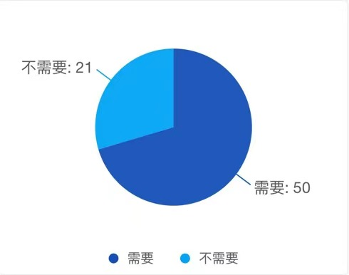

Figure 3-1 Whether a tutorial is needed

**b) User acceptance**

In fact, most users are willing to accept the birth of apps such as this product while they

need the help of tutorials. According to the survey results, more than 78% of them are willing

to accept and use apps of this product type (see Figure 3-2). At the same time, it also shows

that this product has a certain degree of user acceptance in the market, and there is a good

development market.

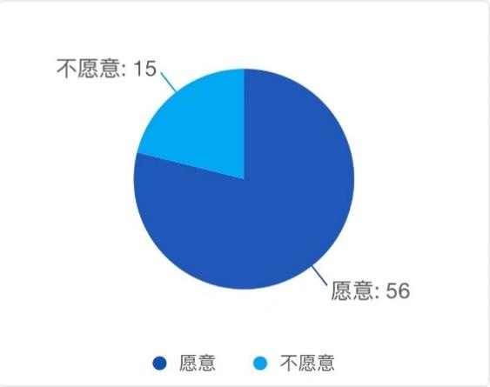

Figure 3-2 Whether this type of APP is accepted

**V.Correct marketing channels**

**1. Early publicity**

a) Social media promotion: Social media is one of the best channels to promote beauty, fitness,

clothing and other fashion areas. We can post content on Instagram, Weibo, Douyin,

Xiaohongshu and other platforms, including fashion information, makeup tips, fitness training,

dressing and matching, and provide App download links. At the same time, we can cooperate

with influential fashion bloggers and Kols to expand the visibility of the App.

b) Establish the App's official blog, community, forum, etc., to increase the App's influence and

user engagement.

c) Advertising: Advertising can be carried out on social media, search engines, App stores and

other channels to increase APP exposure and download. Paid advertising services can be used,

such as Tiktok advertising, Weibo advertising, Facebook advertising, Twitter advertising and so on.

These platforms can help us to target audiences and improve the advertising effect.

d) Email marketing: Marketing emails can be sent to potential users through email, introducing

the functions and features of the App, and providing the download link of the App. At the same

time, emails can be sent to existing users regularly, introducing new fashion information, special

offers, new functions, etc., to improve user retention and loyalty.

e) Traditional advertising media: Advertisements can be published on magazines, newspapers,

subways, buses and other traditional media to improve App exposure and user engagement.

**2. Marketing and promotion**

a) Word-of-mouth marketing: Users in fashion fields such as beauty, fitness and dressing like to

share their experiences and opinions. By providing high-quality user experience, we can

encourage users to spread our App by word-of-mouth. We can provide coupons, discount codes,

free trials and other ways to encourage users to leave favorable comments and recommend them

to friends.

b) Cooperative promotion: We can cooperate with fashion brands, beauty brands, fitness brands,

wear brands, etc., for example, we can cooperate with beauty brands to launch special discount

packages, and cooperate with fitness brands to launch fitness trainer videos, etc., in order to

increase App exposure and user engagement.

c) Exhibition activities: you can participate in fashion, beauty, fitness and other related

exhibitions and activities to show the functions and features of the App, and provide on-site

experience and promotional activities to increase user participation and exposure.

In addition, we need to select appropriate marketing channels and promotion strategies

according to the target users and market characteristics, as well as the marketing strategies of

other competitive products, in order to maximize the exposure and user engagement of the App

and achieve commercial success.